EMBARGOED FOR RELEASE
ON JUNE 9, 2022

Media Contact
Sarah Leichnetz
pr@bearvault.com

Size Matters to Backpackers: BearVault® Launches Two Smaller Bear Canisters

Louisville, Colorado - BearVault, the leading outdoor brand in portable bear canisters, today unveiled two smaller bear canisters, the BV425 Sprint and the BV475 Trek. The BearVault product line now has four sizes, allowing backpackers to make efficient packing choices for any length of trip or size of group.
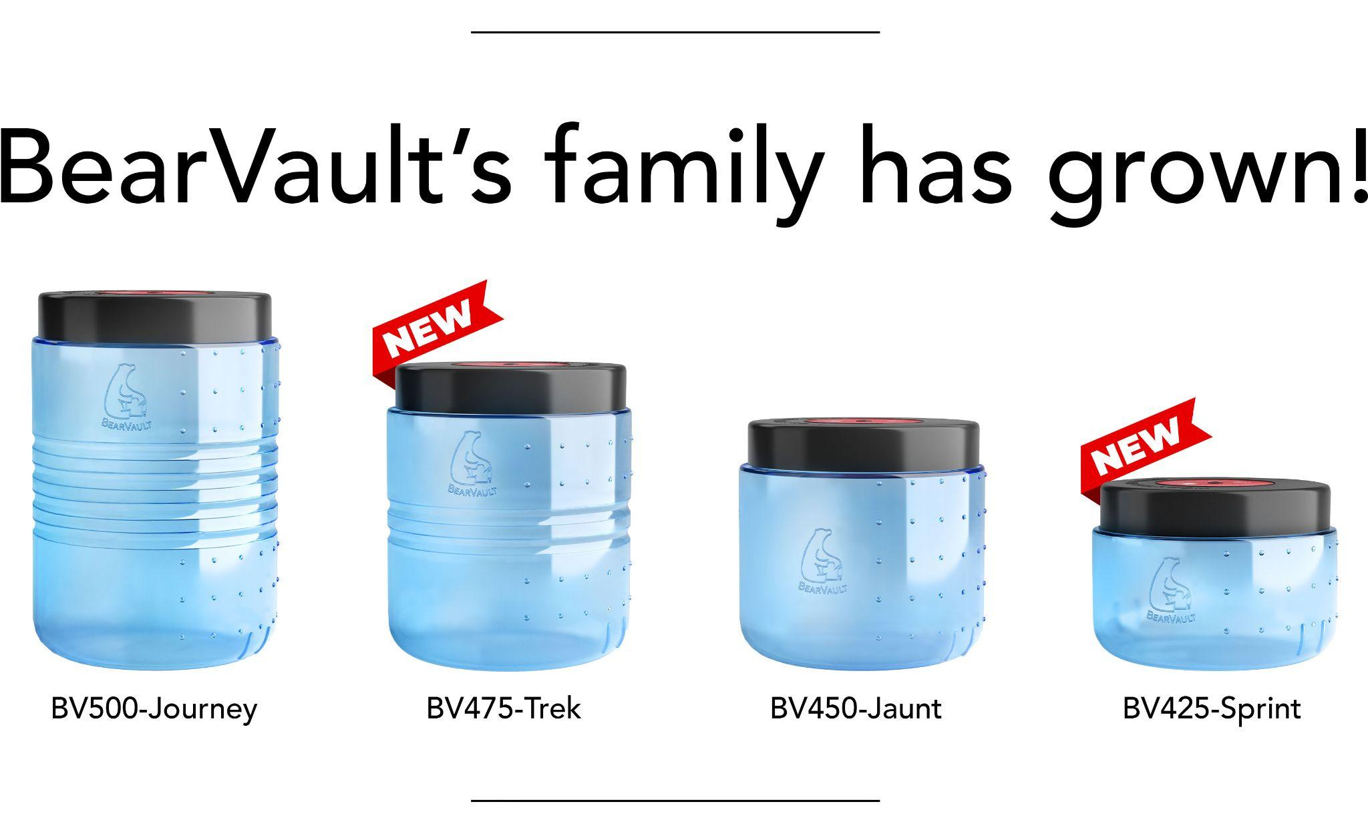
Since BearVault’s classic bear canisters first hit the trails in 2004, backpacks have become more compact, while access to dehydrated food options has improved hikers’ food packing efficiency. Demand for smaller canister options has grown even stronger with the recent boom in outdoor participation, a wider diversity of users, and a broader range of adventures.

“We are excited to now offer a full suite of bear canister sizes for every hiker, every trip, and for the sake of every bear,” said Tracy Twist, BearVault’s president. “With four perfect fit options to choose from, it is easier than ever to safely store food away from bears and wildlife.”

The new models passed the official Interagency Grizzly Bear Committee (IGBC) grizzly bear testing standards in May of 2022. Made in the USA of specialty polycarbonate and other durable resins, they will be available to ship by mid June.

New model details:

BV425 Sprint (MSRP $73.50): 1.3 Gal capacity, weighing 1.75 lb, standing 6” tall. The smallest in the BearVault family of canisters, the BV425 Sprint is designed for overnight trips, for youth or smaller backpackers, and for groups who share the food load among all hikers. This compact model also solves the food storage quandary for day trippers who leave their lunch at a base while enjoying nature - fishing, hunting, or climbing.

BV475 Trek (MSRP $86.95): 2.5 Gal capacity, weighing 2.3 lb, standing 10.5” tall. A mid size canister in between the classic BV450 and BV500 sizes, the BV475 Trek is well suited to families or groups, a couple backpacking for a few days, or to long distance hikers who prioritize compact food storage and high volume to weight ratios.

##
About BearVault

BearVault® is the leading manufacturer of bear-resistant food canisters for backpackers and outdoor enthusiasts. BearVault is known for its clear, wide opening, tool-free canisters that make it easy for people to protect their food from animals. Based at the foot of the Rockies in Louisville, Colorado, BearVault is a values driven, carbon positive company that integrates sustainability and wildlife conservation into its business practices. Please visit us at www.bearvault.com, Instagram: BearVault, Facebook: BearVaultCanisters, TikTok: BearVaultCanisters.

